Fluffy Character Based Information Trustworthiness Reviewing for Dependable Cloud Capacity Frameworks.

Ashwin Kumar D, Dhesh Kumaar A, Balaji R, N. Sathish Students +, Assistant Professor+

+Department of Computer Science Engineering,

+Panimalar Engineering College, Chennai,

Tamilnadu, India

their data and may not know where their data is

***Abstract***— The nature of the information, a security issue in a secure area, has received much consideration. Conference evaluation information enables the notary to humbly assess the validity of retransmitted information without downloading the data. A major research challenge related to existing knowledge analysis frameworks is a multi-faceted environment in critical management. We try to fix the confusing key in mind the board’s challenge in looking at the reliability of cloud information by presenting character-based reviews, first in that way, with all our understanding. Specifically, we present a critique of personality-based information that explores details, in which a client character can be seen as a multi-faceted feature. We formalize the framework model and the security model for this new platform. At the same time we present a strong development of personality based on exploring the assembly using biometric as a disruptive character. The new agreement provides an asset for the firmness of errors, in particular, it combines a secret key for one character that can be used to assess the validity of a response made by another character, if and only if that character is close enough. Finally, we have created a model for the use of assembly that reflects the general idea of a proposal.

**Keywords —** Cloud Storage, Data Integrity, Fuzzy Identity**.**

# INTRODUCTION

As a basic service of the IaaS (Infrastructure as a service) model on cloud computing, cloud storage enables data holders to store their files in the cloud and delete local data, which greatly reduces the burden of data storage and management. Cloud storage has many eye-catching features, mean access to global data, local geographical areas, self- service, resource intensity and so on. Currently, both you and large companies enjoy the benefits of cloud storage services. In addition to the benefits offered by cloud storage, there are many natural security risks. For example, when data owners take their data out of the cloud, they often lose control of

actually stored or who has access to their data. That is to say, cloud servers control data creation after data owners upload their files to the cloud. While many cloud service providers are trustworthy (e.g., due to their interest in ensuring a good reputation and avoiding public charges), incidents of data loss are inevitable. As a result, data owners need a strong guarantee of the integrity of their exported data and want to ensure that cloud servers properly store their data. Therefore, the integrity of cloud data is critical to secure and reliable cloud storage. To solve the problems listed above, RDIC is also known as data integrity research, which involves three groups, namely: cloud server, data holder and third party auditor (TPA). The publicly verified protocol allows TPA or anyone else to check the authenticity of data stored in the cloud without the need to access all of the database. In this sense, the data owner has two public / private keys (pk and sk respectively), where sk is used to generate block authentication and pk is used to verify authentication generated by the cloud server. In other words, these programs are based on key public infrastructure (PKI), which includes a certification authority (CA) that issues and certificates digital certificates, a registration authority that verifies the identity of users requesting information from CA, a centralized directory, and a certificate management system. Agreements based on PKI have two important limitations. First, the processing, management and disposal of certificates is complex and costly, and as a result declining is a challenge. Second, the level of trust the demand for CA can be absurd, especially given the recent high-profile incidents. For example, in May 2015, a number of unauthorized digital certificates were issued by the Egyptian CA, which could assist in a vicious attack. Another popular PKI (and simplified system of complex certificate management) is the proprietary (ID-based) cryptosystem proposed by Shamir in 1984 that binds the user's private key, without the need for a digital certificate. Since then, several ID-based schemes have been proposed (including remote data research protocols). As recently as 2015, for example, several ID-based data research

agreements were proposed, and in these processes, identity data is an undisputed thread. The latter contains the username, IP address and email address, which allows the user to register a private key corresponding to his or her identity in the private key generator. Although ID-based cryptosystems solve the need for complex certificate management, there are many limitations to such systems. For example, a user's identity may not be truly different if the identity details are not properly selected (e.g., using a common name such as "John Smith") . However, supporting documents are less than fraudulent. Generally, both ID and PKI-based schemes are based on what you know (e.g., ID details) and what you have (e.g., digital certificate and password). Recently, the complexity of the complexity of the problem is increasing, and the opposite is true. Biometrics, like the most common type of complex identity, are based on who you are. In other words, biometric-based schemes authorize or identify the user based on physical or behavioral features (e.g. fingers, iris and facial features) and are included in real-world applications (e.g. biometric passports and mobile devices such as Apple iOS Phones and Samsung). This is not surprising, given the benefits offered by biometric systems. For example, biometric-based IDs are easily portable and are not corrupt or misplaced. But in biometric schemes, the data owner needs to transfer his or her identity to the Key Generating Center (KGC) to obtain an encryption key that could lead to security issues as KGC knows the biometric identity and encryption key that can be used by attackers to access user cloud data. Therefore, we decided to eliminate this problem by introducing the concept of tokens, the idea that the data owner sends his biometric identity to the TPA and then the TPA returns the unique token to the user according to his biometric. Data owner and send cloud data. Therefore, we decided to eliminate this problem by introducing the concept of tokens, the idea that the data owner sends his biometric identity to the TPA and then the TPA returns the unique token to the user according to his biometric. The data owner then submits his or her unique token to KGC to obtain the encryption key so KGC does not know the biometric identity of the data owner, all they know is that it is a separate token and encryption key and not the user's biometric identity, so the attacker will not know which one a user who uses a different token.

# EXISTING SYSTEM

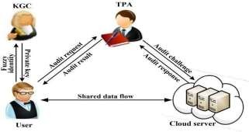

When data owners transfer their data to the cloud, they often lose control of their data and may not know where their data is actually stored by anyone with access to their data. As a result, data owners need a strong guarantee of the integrity of their exported data and want to ensure that cloud servers properly store their data. To solve the problems listed above there are a number of ID-based programs (including remote data testing principles) proposed for example, several data research agreements for IDs were proposed and, in these processes, patent information is an undisputed thread. There are many limitations to such programs. For example, a user's identity may not be truly different if the identity details are not properly selected Secondly, the user needs to "prove" the secret key generator center that you really have the required patent, such as presenting a legal document to support the claim. However, supporting documents are less than fraudulent. Generally, both ID-based and PKI- based schemes depend on what you know (e.g., ID details) and what you have (e.g., digital certificate and password)

**DISADVANTAGES**:

* A major research challenge associated with existing data protocol projects is complex in critical management.
* PKI agreements with two important limitations. First, the processing, management and disposal of certificates is complex and costly, so downgrading is a challenge
* Second, the level of trust required by the CA may be unrealistic, especially due to recent high-profile incidents

# PROPOSED SYSTEM

In the existing system, the KGC is designed in such a way that it receives the biometric identity in order to provide the encryption key which may lead to security problem as the KGC knows both the biometric identity and encryption key of the person which can then be used by some attackers to have access to the cloud data. So, we overcome this issue by designing the KGC in such a way that it receives the unique token from the data owner (token is provided to the user based on biometric identity by the TPA) and provides an encryption key corresponding to the unique token to the data owner. As a result, the TPA only knows the biometric identity not the encryption key and the KGC only knows the unique token not the biometric identity. The cloud server is used only to save the encrypted blocks of data.

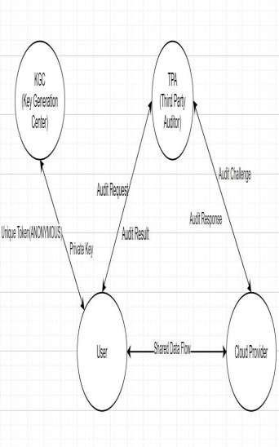

**ADVANTAGES:**

* + We want to address the key management challenge in assessing the integrity of data by introducing anonymous patent- based research
  + Biometric-based IDs are easily portable and are not corrupt or misplaced.
  + Protecting protocol based on computational Diffie-Hellman assumptions and alternative logarithm assumptions on the selected ID security model.
  +  Promoted confidential sharing schemes used to store sensitive and sensitive information.

# ALGORITHMS USED AND ITS WORKING

There is a need to create a public audit system that overcomes the existing audit system. The proposed system was developed to ensure the accuracy of cloud data by TPA, periodically or on demand without access to all data or without introducing additional online responsibility to cloud users and cloud servers. Ensures that no data content is disclosed to TPA during the testing process. Maintains the accuracy of data retention, integrity and privacy of the database. The proposed plan consists of four basic elements; they are data owners, Key Generating Center (KGC), cloud storage and Third-Party Auditor (TPA). The data owner sends his biometric identity (fingerprint or iris) to the TPA and the TPA returns a unique token depending on its biometric identity. After that the data owner sends a unique token to KGC without revealing his identity to obtain the encryption key, KGC returns the encryption key that corresponds to the different token received. The data owner or user is responsible for splitting the file into blocks, encrypting those using the AES algorithm, creating a SHA-2 value for each hash, merging hashes and producing an RSA signature on it. The cloud server is used to store encrypted files. When a client or data owner requests a data test from TPA, they immediately request encrypted data from the cloud server. After receiving the details, it generated a hash value for each encrypted file block. It uses the same SHA-2 algorithm used by the client. It later incorporates those hash values and generates an RSA signature for that file. In the verification process, the signature generated by the TPA and

the one stored in the TPA provided by the data user are compared with the TPA. If they are the same it means that the data is accurate and the data is not disturbed by any outsider or attacker. If not, it indicates that the integrity of the data is affected or disrupted. The result of a data integrity test is provided to the data owner. Data owner is an integral part of our proposed system. Make a big data-related burden. In the proposed audit plan, the data owner first performs login and registration via the cloud server and TPA. The new user must first register by completing the registration form and become an active member of the program. A message for successful registration will be provided. If the user is already a member of the program then they can perform the login process. If the username and password are in the database, then they will be successfully logged in as legitimate users or else they will receive an error message.

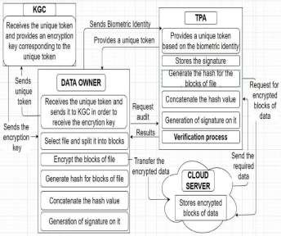

**Proposed Auditing scheme Architecture**

If you are logged in successfully, the data owner will select the file they want to store on the cloud server. The file he selected will be divided into multiple blocks. To perform the required file sorting on blocks using the File Splitter algorithm. In this algorithm, we check whether the file exists or not. If there is a case where the file is sorted by a certain size based on the file size. For example, if a file is 23kb in size then it will be split into 20kb and 3kb. Here's an example of a file size limit of 20kb. Next, we use a strong encryption algorithm Advanced Encryption Standard algorithm (AES) to provide confidentiality to data. Blocks split is now encrypted using the AES algorithm by the data holder. Blocks of each file will be encrypted and stored on the client. A copy of the encrypted file will be transferred to the cloud server for storage purposes. Writes data in 128-bit data blocks using 128-bit

measurement keys. After encrypting blocks, now a block hash number is generated separately. For this purpose, the hashing algorithm SHA-2 is used. After the hashes were generated, the hashes of each block were tightened and an RSA digital signature was made on it. Digital signatures are used to verify the source of the messages. This signature is later sent to TPA, where we use this signature to check the authenticity of the data stored in the cloud server storage is stored or not. The data owner has the right to request that data integrity be considered at TPA

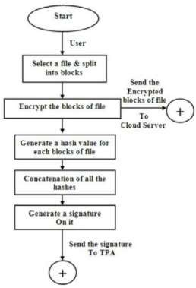

**Flowchart for working of Data Owner**

The data owner uses cloud storage to store the data privacy form. As data is stored encrypted, so the cloud server has more complex information. And if a cloud server becomes a malicious server or is attacked by any external invader, the data will not be readily available as it is in encrypted form and is not aware of the encryption algorithm developed by the data owner. In the proposed system, to perform this data research function TPA was used for this purpose. TPA performs data testing periodically or at the request of the customer. Upon receipt of a research request from a user or data owner, TPA begins its evaluation process. TPA also maintains a signature which is created by the data owner. TPA follows the same process by the data owner such as generating hash blocks of file blocks, assembling them and making a signature on them. It later compares the two signatures with the verification process. If it is

identical it means that the integrity of the data is maintained and otherwise it is not maintained. This means that the data is not tampered with or altered. The same results are given to TPA by the data owner.

# CONCLUSION

The existing system is designed in such a way that the data owner sends his biometric identity to KGC to obtain the encryption key that could lead to security issues as KGC knows the biometric identity and encryption key that can be used by attackers to access user cloud information. and privacy that uses the token concept, The concept is that the data owner sends his biometric identity to the TPA and then the TPA returns the unique token to the user depending on the biometric obtained. The data owner then sends a unique token to KGC to get the encryption key, as a result KGC only knows the unique token and encryption key, so the attacker does not know which user is using a different token.

# REFERENCES

1. Yannan Li, Yong Yu_, Geyong Min, Willy Susilo, Jianbing Ni and Kim-Kwang Raymond Choo, “Fuzzy Identity-Based Data Integrity Auditing for Reliable Cloud Storage Systems”, IEEE Transactions on Dependable and Secure Computing, Volume: 16, Issue: 1, Jan.-Feb. 1 2019.
2. P. Salil, S. Pankanti and A. K. Jain. “Biometric recognition: Security and privacy concerns.” IEEE Security and Privacy, 2, pp.33-42, 2003.
3. X. Li, J. Li and F. Huang. “A secure cloud storage system supporting privacy- preserving fuzzy deduplication”. Soft Computing, 20(4), pp. 1437- 1448,2016.
4. D. Boneh and M. Franklin. “Identity-based encryption from the weil pairing”, Proc. of CRYPTO 2001, LNCS 2139, pp.213-229, 2001.
5. C.Wang, Q.Wang, K. Ren, andW. Lou, “Privacy-preserving public auditing for data storage security in cloud computing”. Proc. of IEEE INFOCOM, pp.525-533, 2010.
6. Y. Yu, M.H. Au, Y. Mu, S.H. Tang, J. Ren,

W. Susilo and L.J. Dong, “Enhanced privacy of a remote data integrity-checking protocol for secure cloud storage”International Journal of Information Sececurity.14(4), pp.307-318, 2015.

1. C. Wang, K. Ren, W. Lou, and J. Li, “Toward publicly auditable secure cloud data storage services”, IEEE Network, 24, pp.19- 24,2010.
2. Y. Deswarte, J. J. Quisquater and A. Saidane. “Remote integrity checking”. Integrity and Internal Control in Information Systems VI. Springer US, pp.1-11, 2004.
3. F. C. Guo, W. Susilo and Y. Mu. “Distance- Based Encryption: How to Embed Fuzziness in Biometric-Based Encryption”. IEEE Transactions on Information Forensics and Security, 11(2), pp.247-257,2016.
4. P. Yang, Z. Cao and X. Dong. “Fuzzy identity-based signature with applications to biometric authentication”. Computers and Electrical Engineering, 37(4), pp.532-540, 2011.